Installation User Manual

## XAMPP Installation

* Install XAMPP

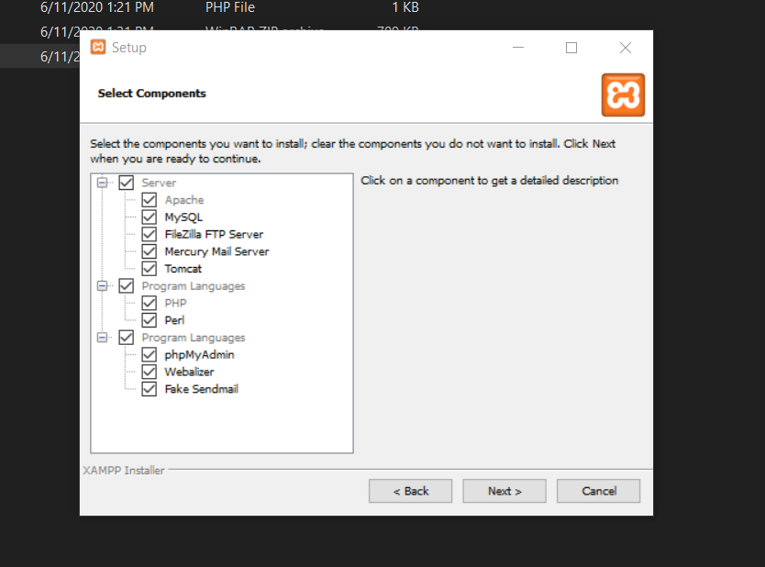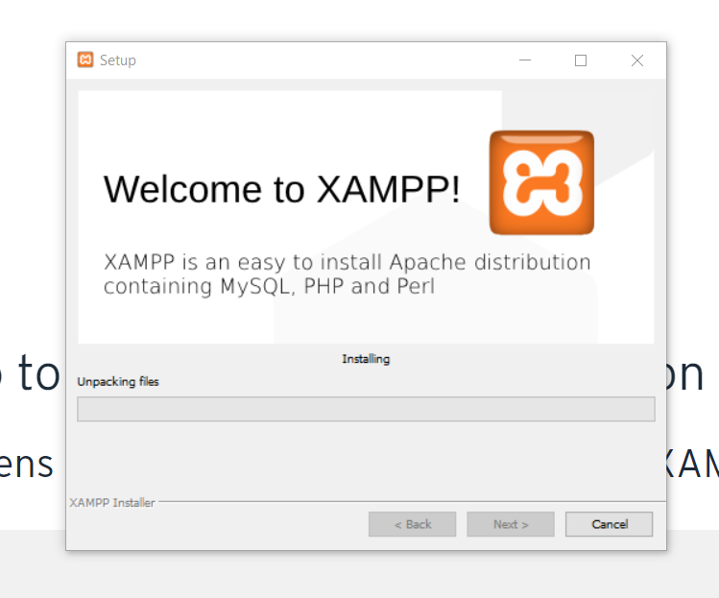

## Oracle XE Installation

* Download Oracle from <https://www.oracle.com/database/technologies/xe-prior-releases.html> and install Oracle XE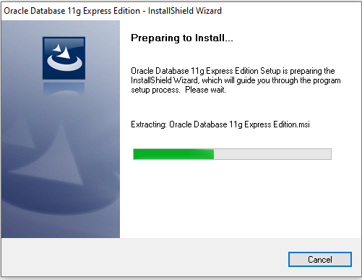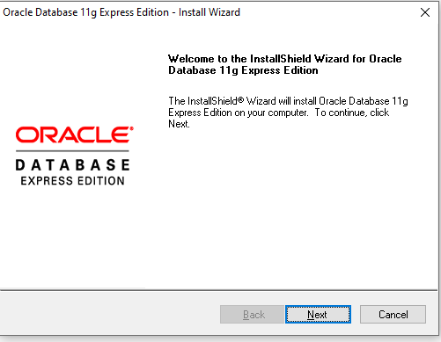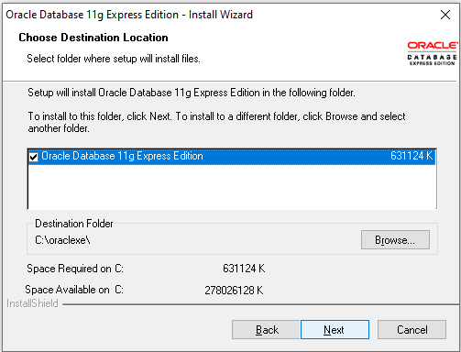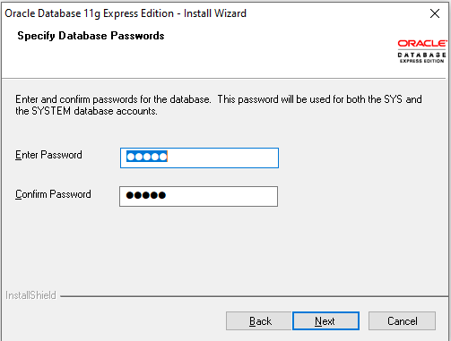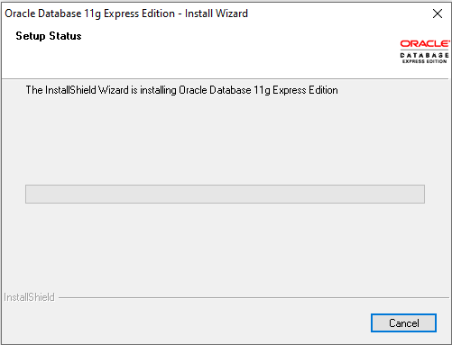

## Oracle APEX update

* Download from the link <https://www.oracle.com/tools/downloads/apex-192-downloads.html> and unzip.
* Copy the sub-folder apex to a location. Suppose C:/ 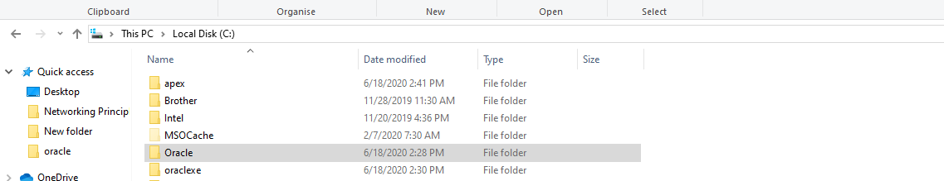
* Go to the folder apex and press Alt + D. This will select the explorer input in the top.
* Type cmd to open the command prompt.
* Alternatively, you can open command prompt and change the directory to this location. 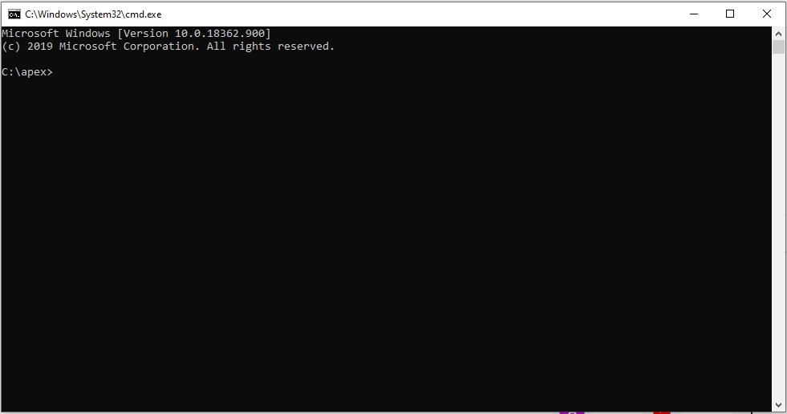
* Start SQL*Plus and connect to the Oracle XE database:

sqlplus /nolog

SQL> CONNECT SYS as SYSDBA

Enter Password: SYS_Password

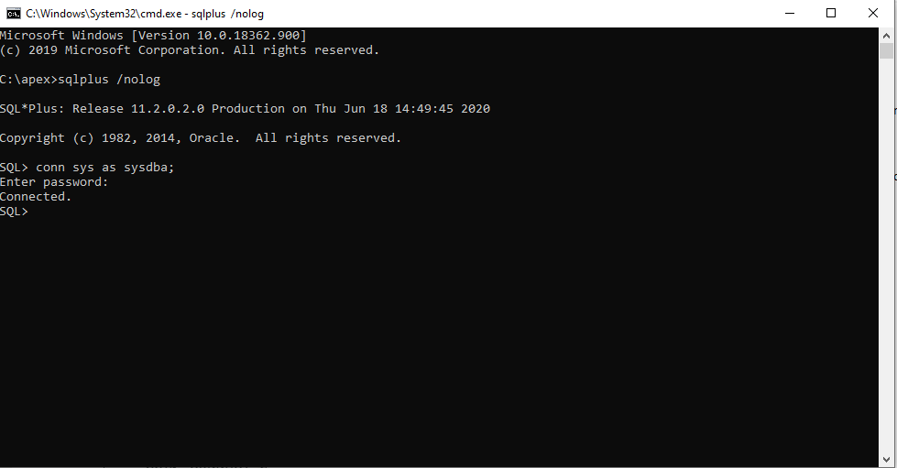

* Install Application Express:

SQL> @apexins SYSAUX SYSAUX TEMP /i/

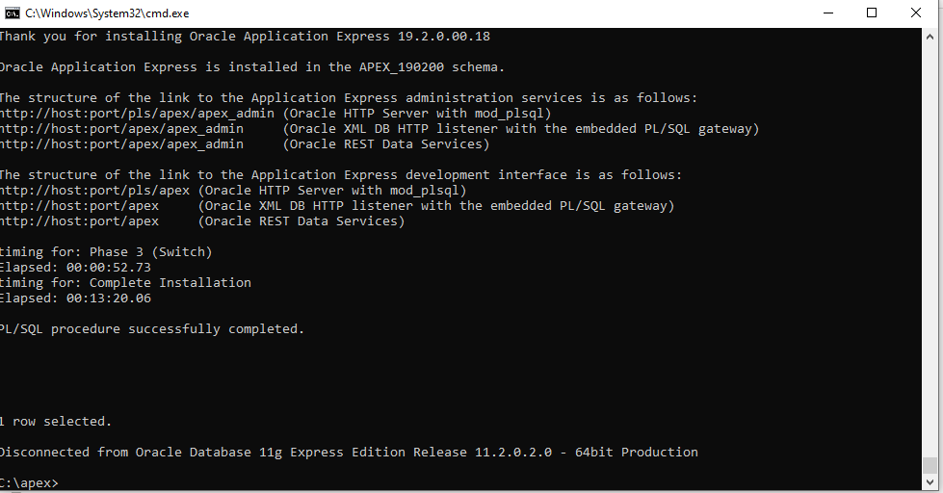

* Log back into SQL*Plus (as above) and configure the Embedded PL/SQL Gateway (EPG):

SQL> @apex_epg_config.sql APEX_HOME

[Note: APEX_HOME is the directory you specified when unzipping the file. For example,

with Windows 'C:\'.]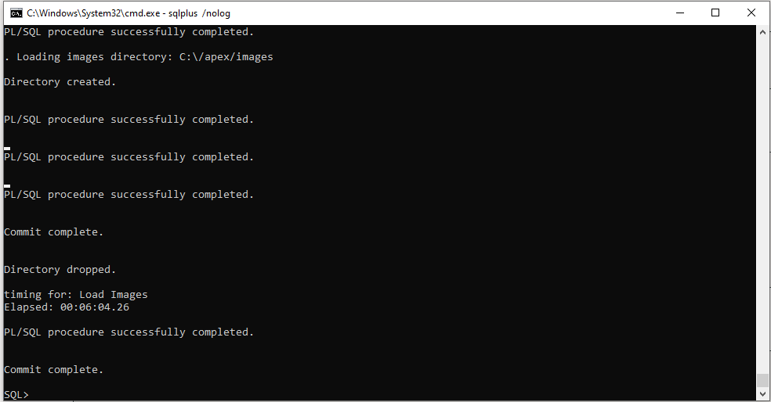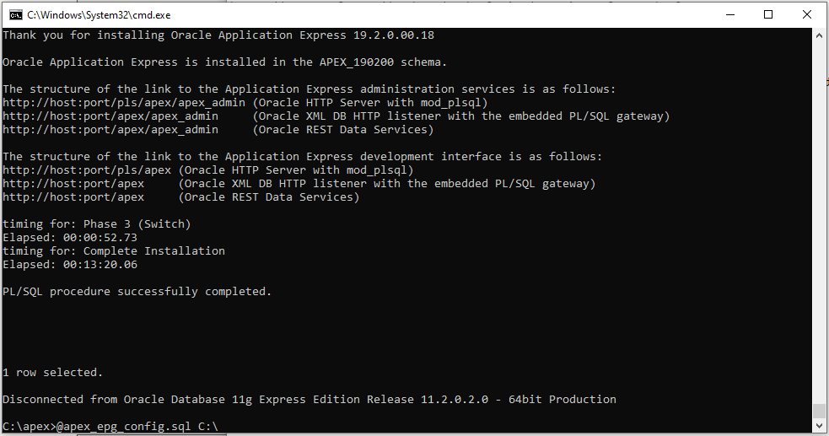

* SQL> @apxchpwd

Enter password for Application Express ADMIN account. 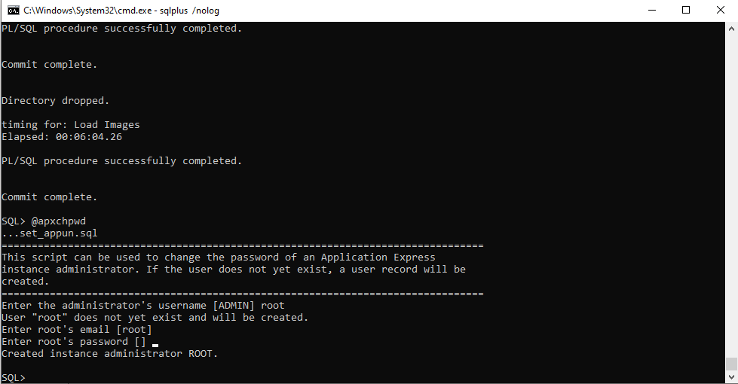

## Oracle Workspace

* Go to link <http://127.0.0.1:8080/apex>  
  and go to administration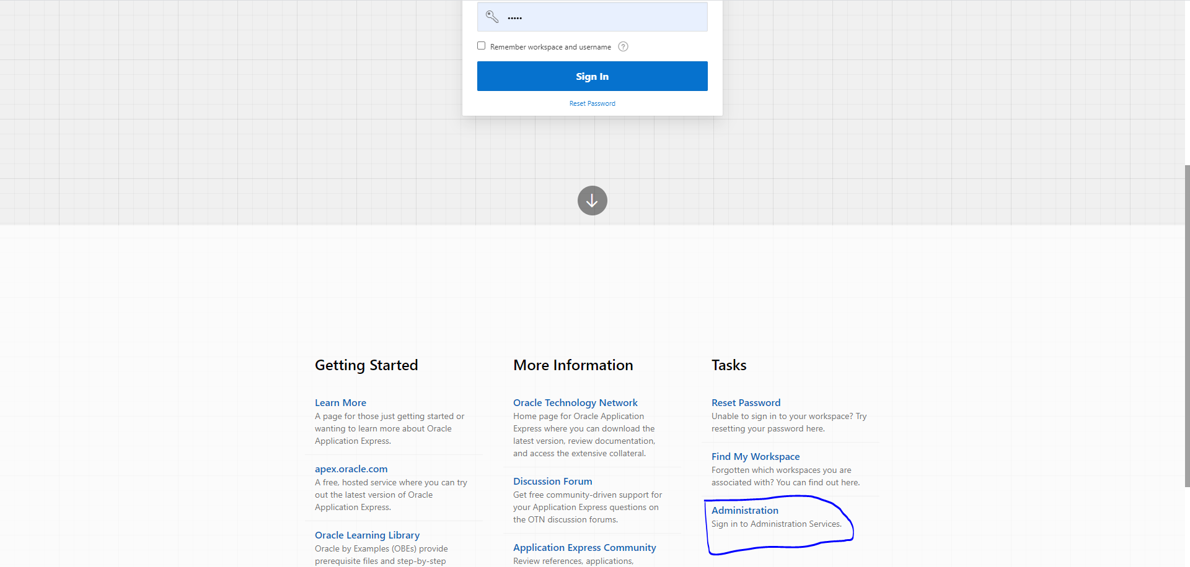
* Login to the user with username and password as set before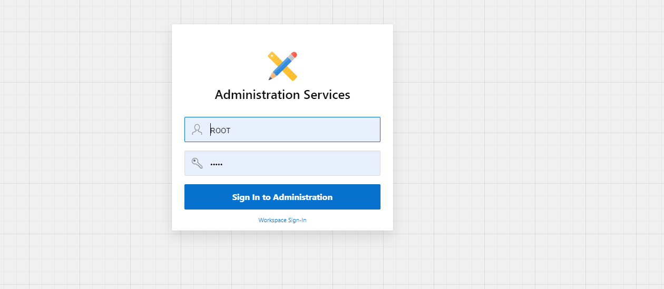
* Create Workspace as prompted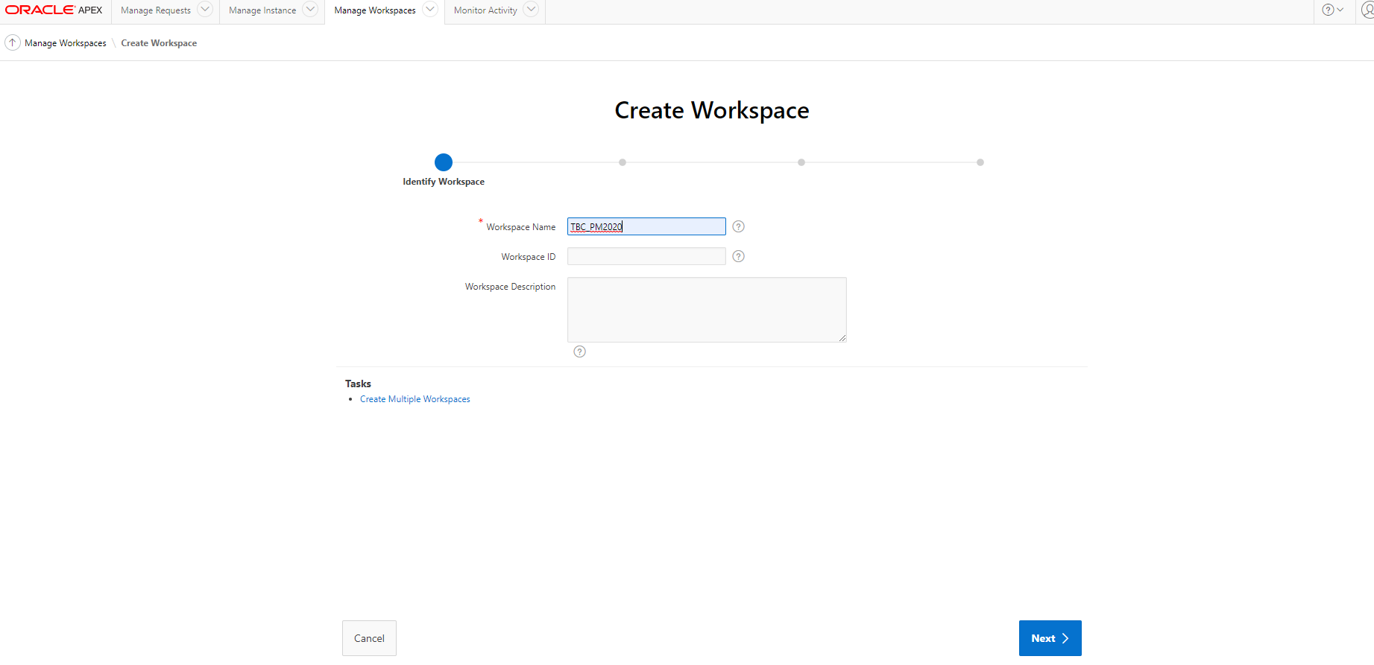

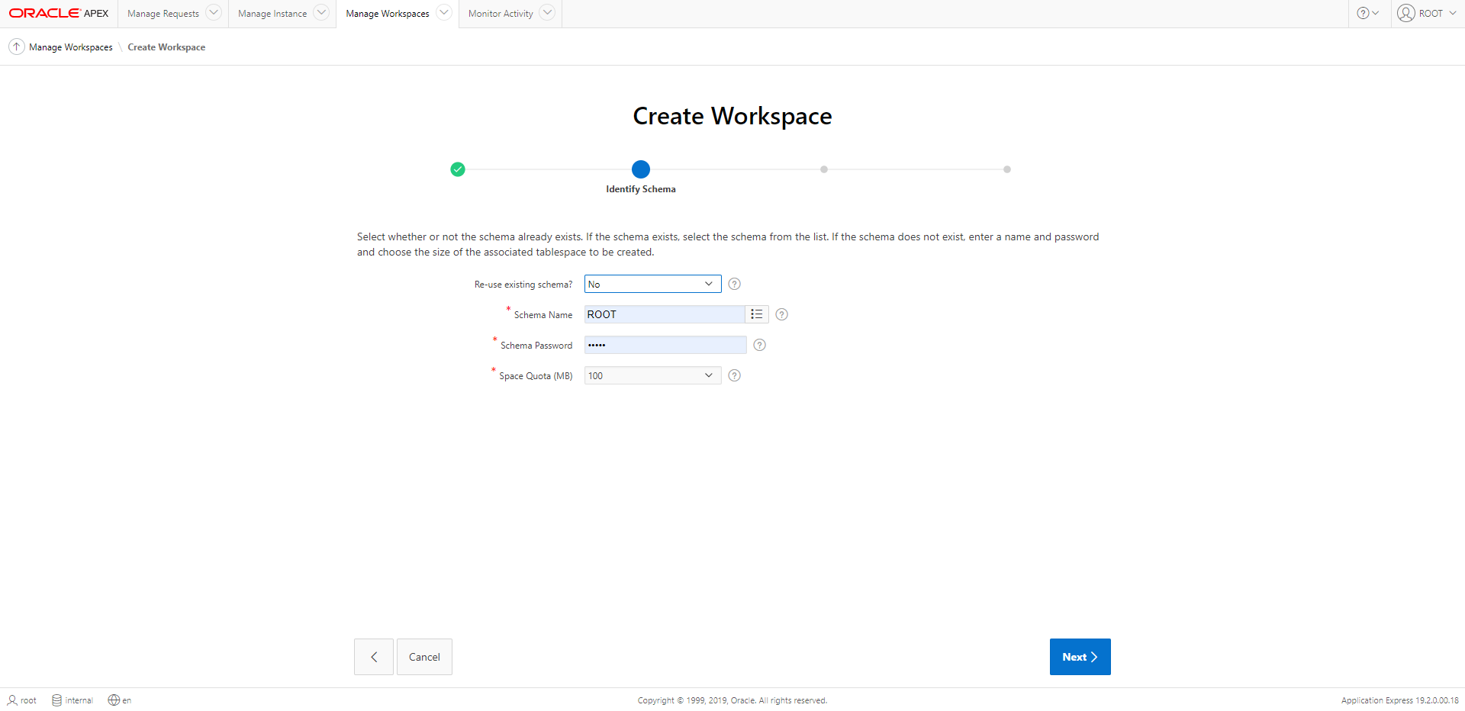

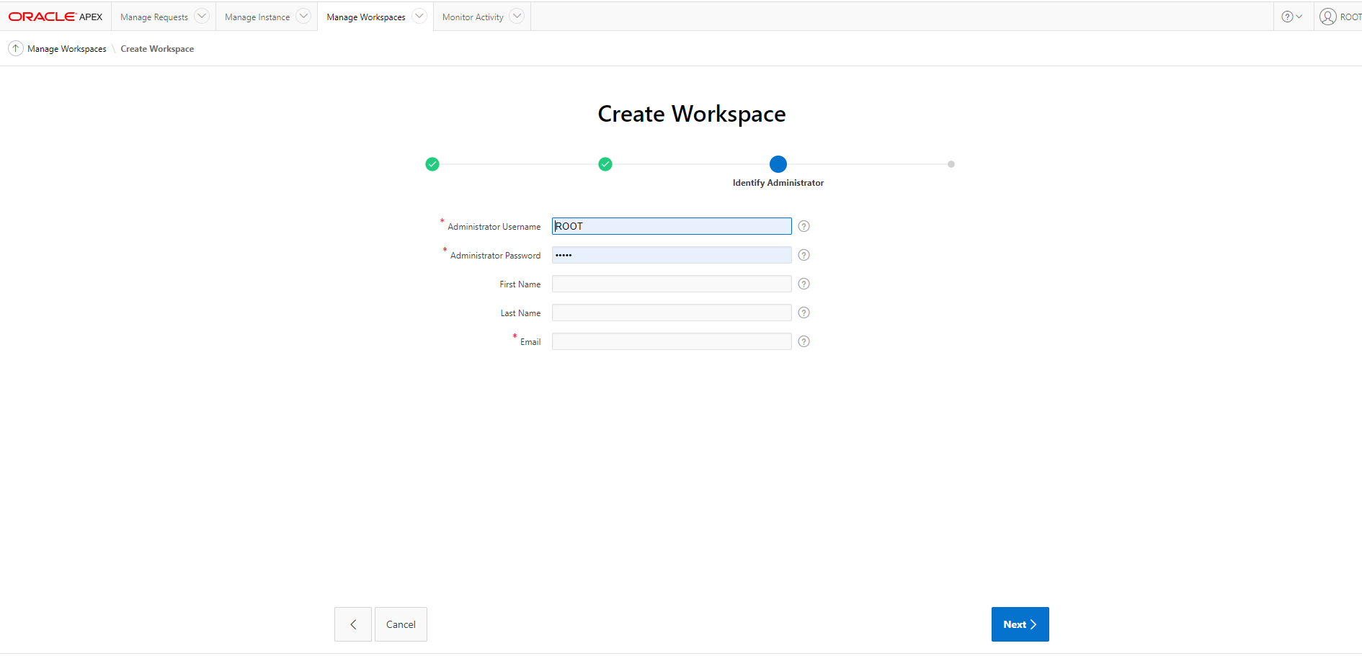

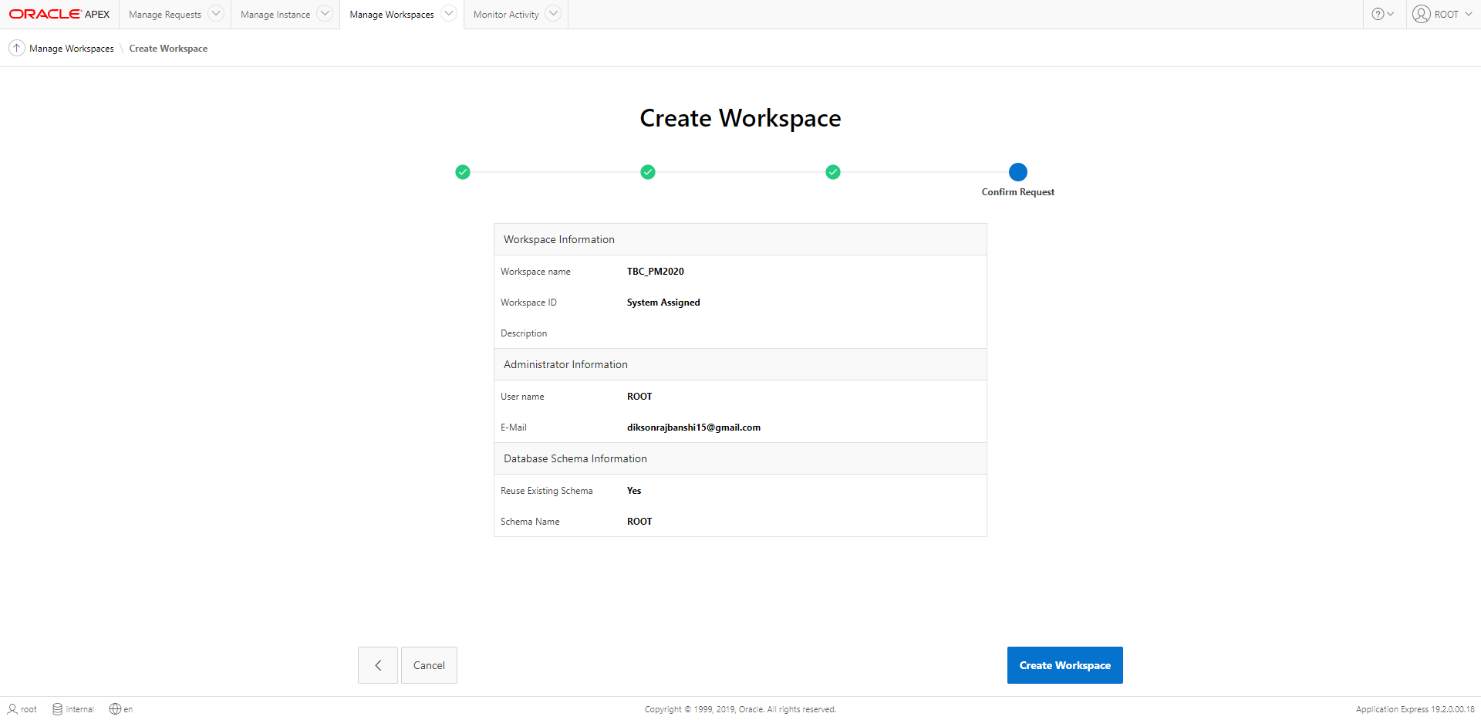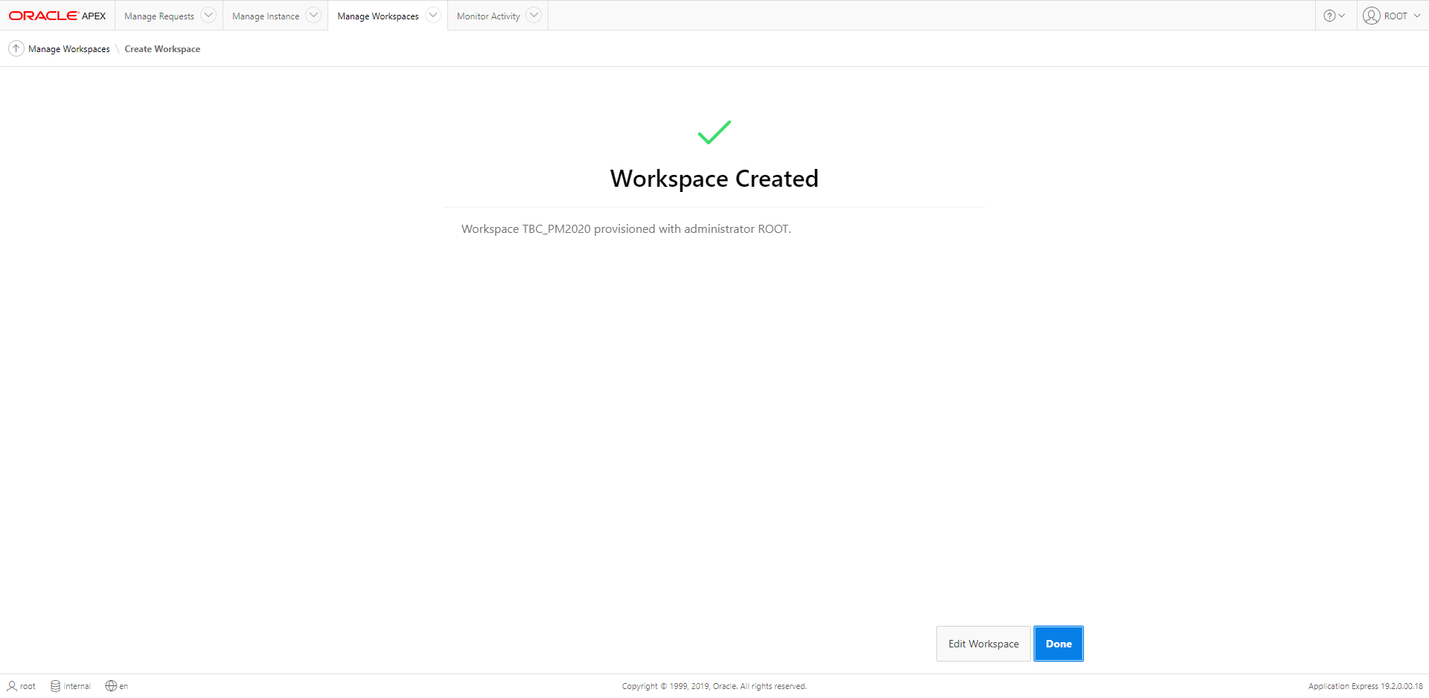

* Login to the workspace with the credentials set up earlier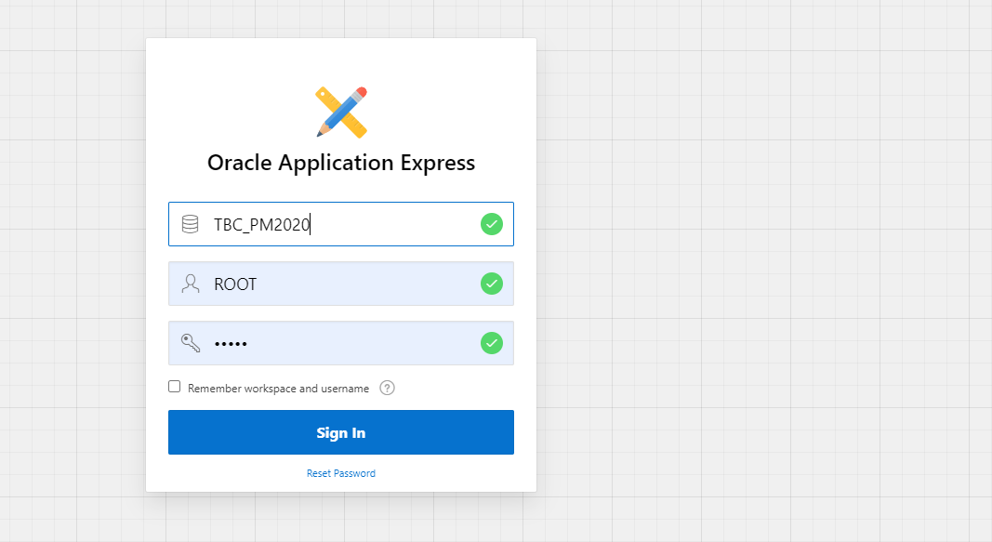
* After login go to SQL workshop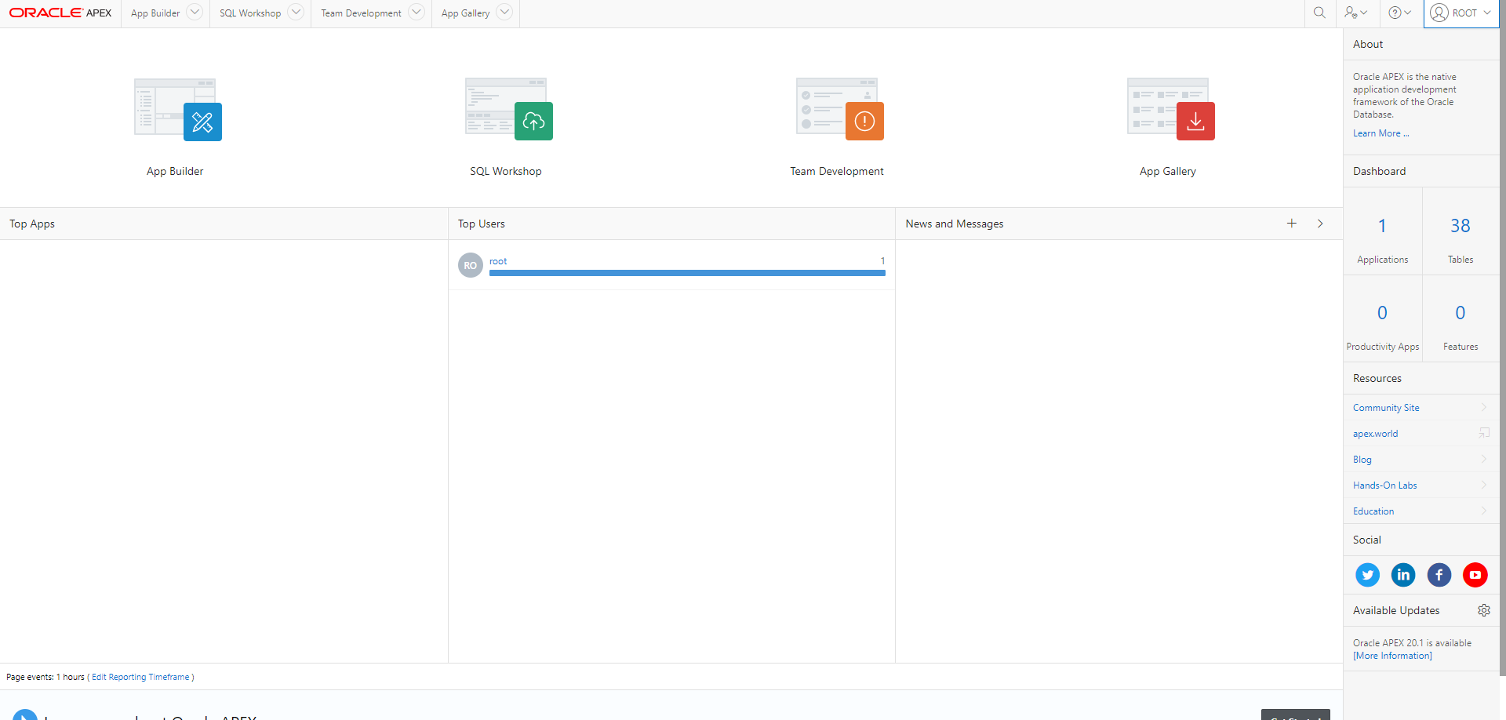
* Then navigate to SQL Scripts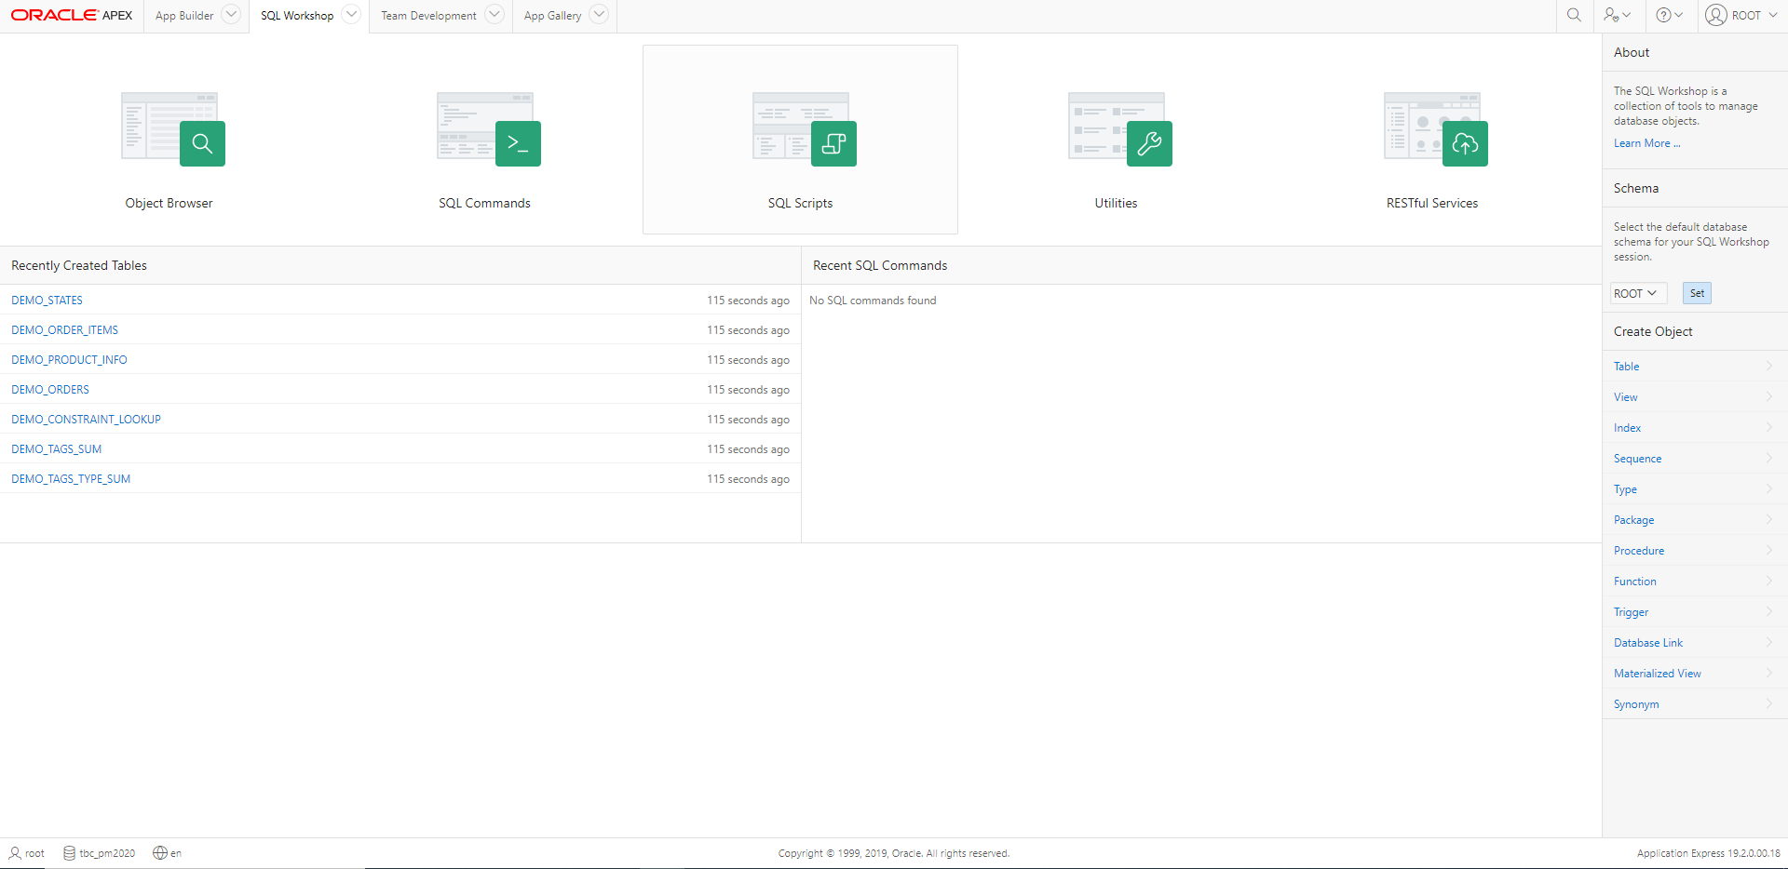
* Upload the export.sql 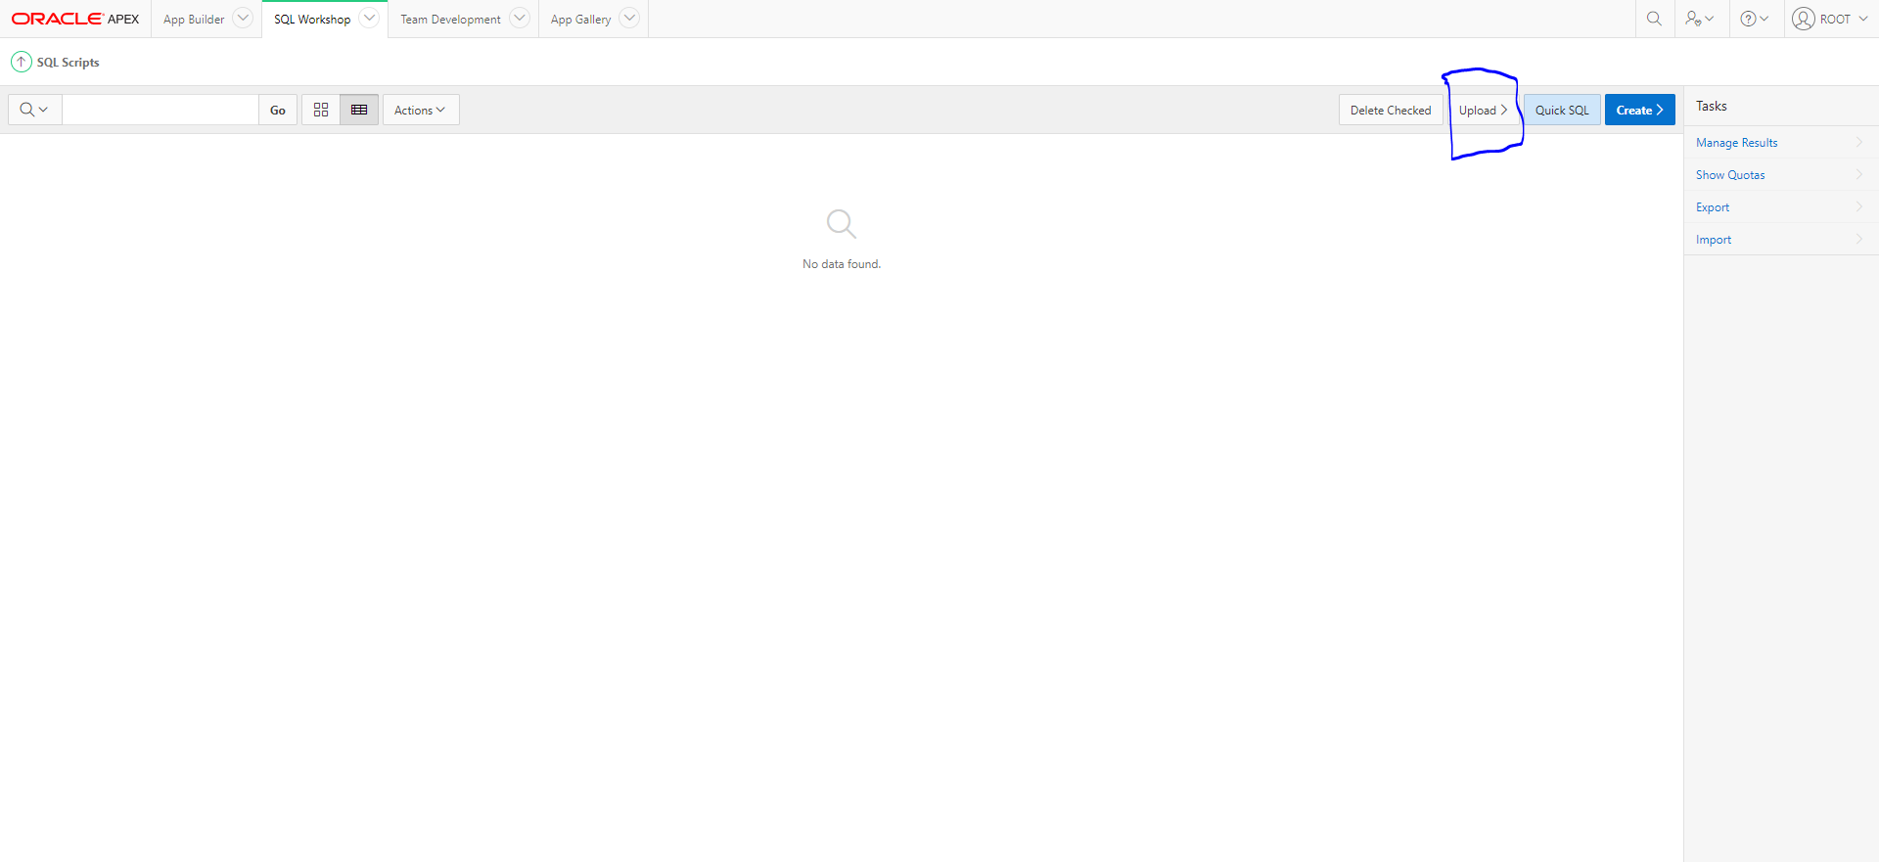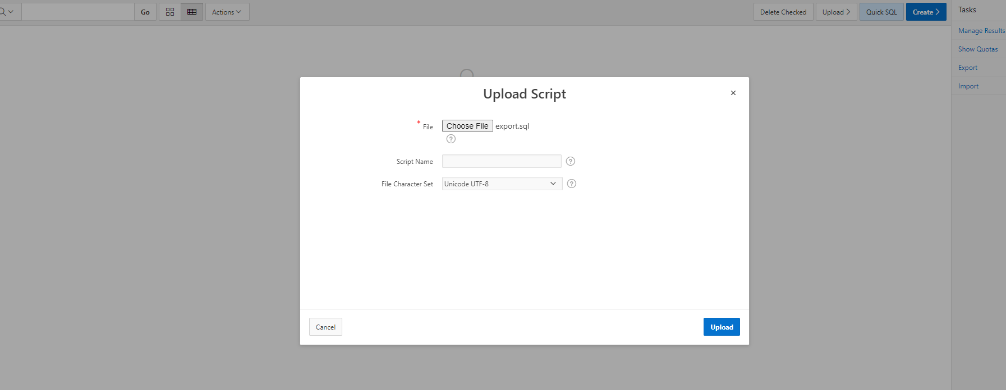
* Run the script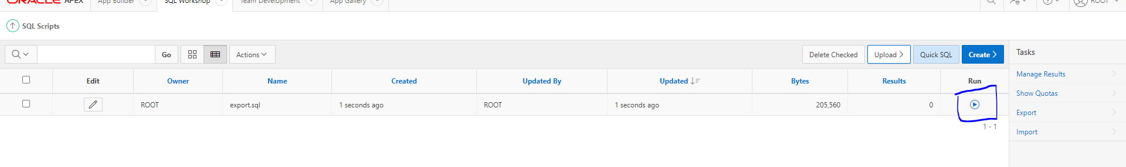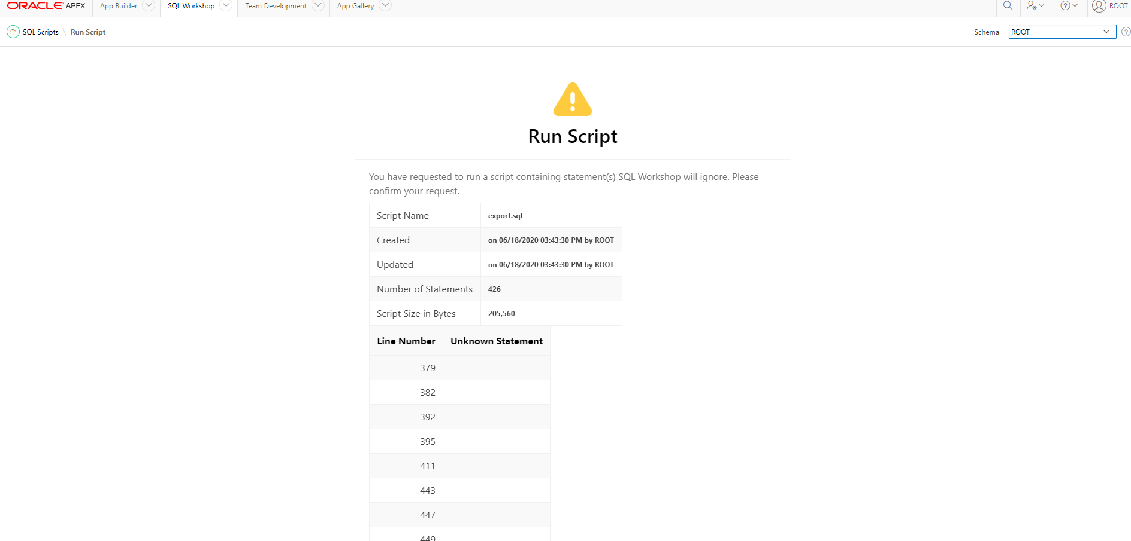
* After script run completion, navigate to App Builder and click on Import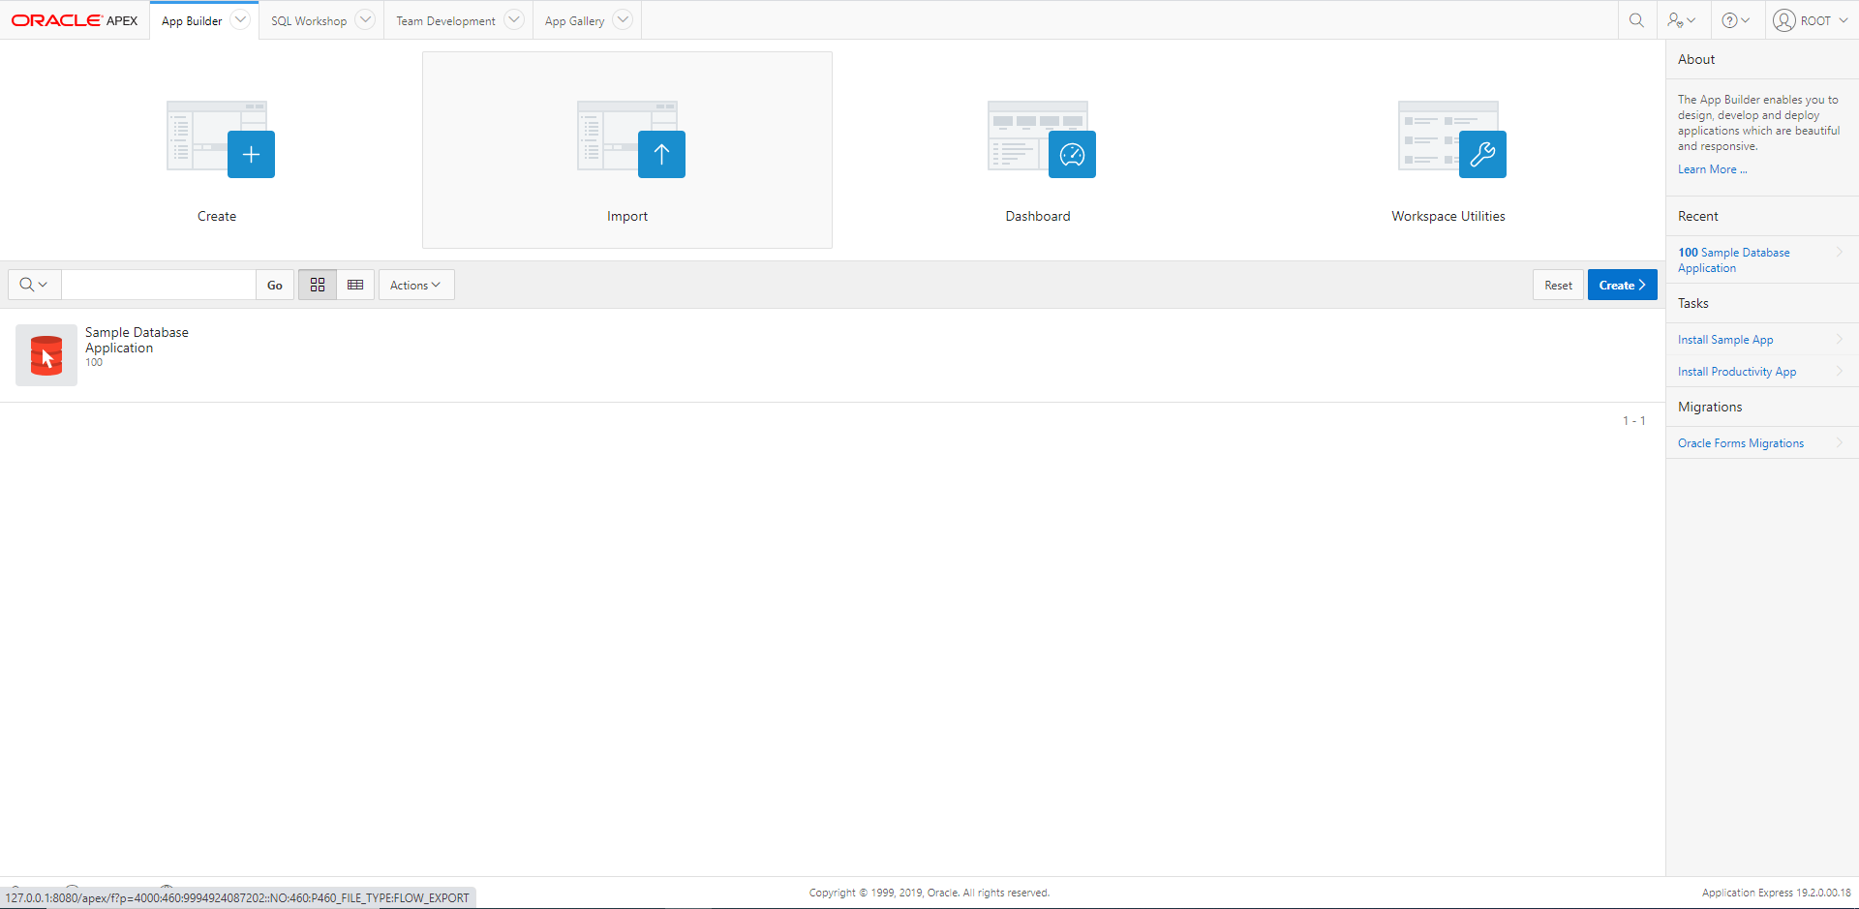
* Import the f103.sql file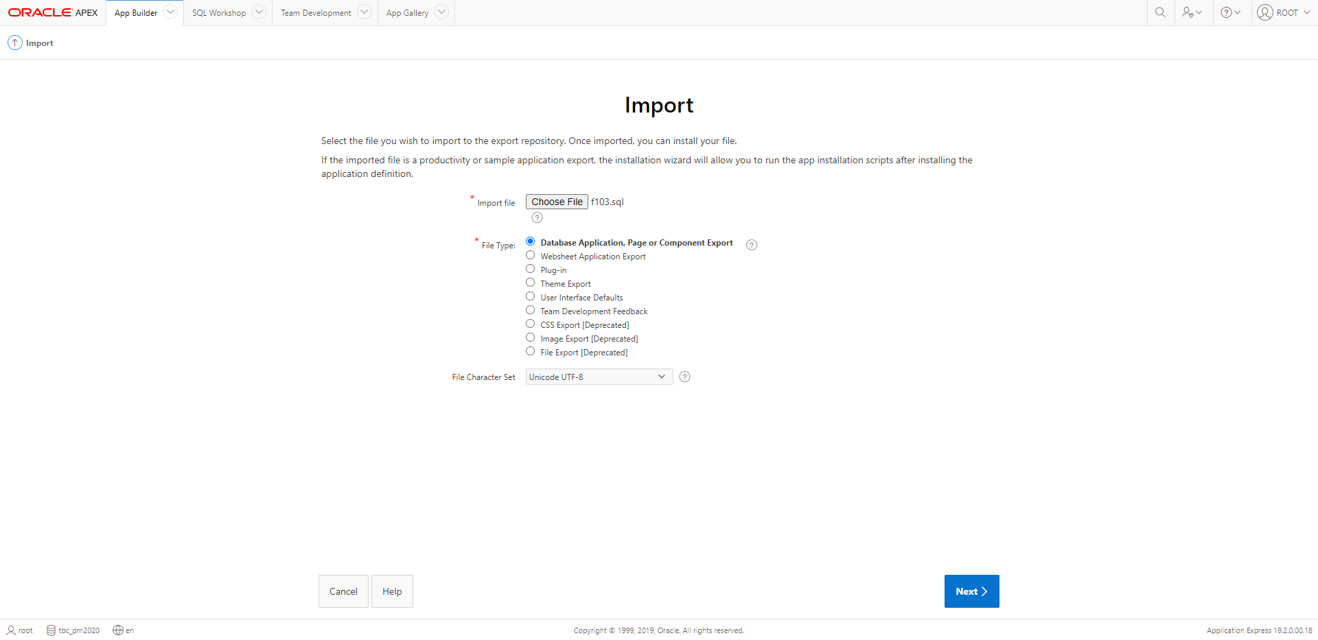
* Install the application

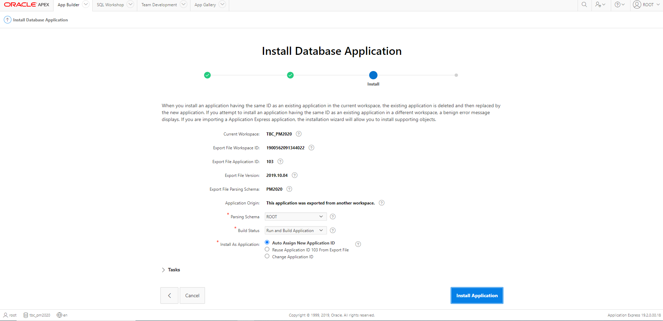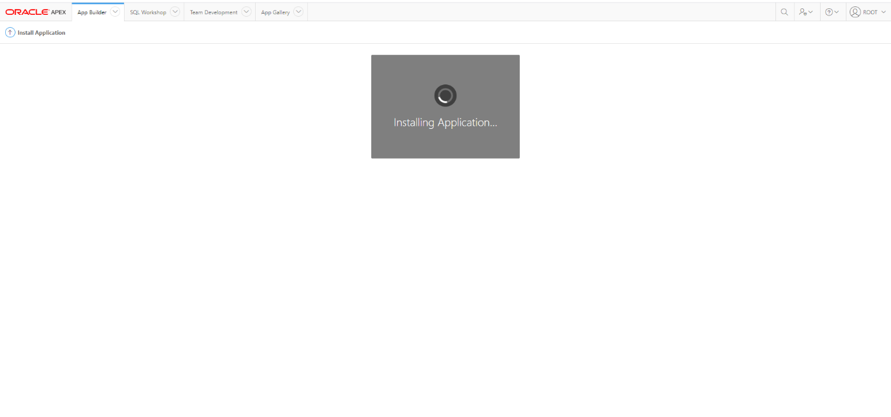

* After installation, go back to the command prompt with SQL and enter the command  
  SQL> grant execute on dbms_crypto to <user>;
  + Here, root is the required user

## Add PHP Path

* In Control Panel, go to System > Advanced system settings. 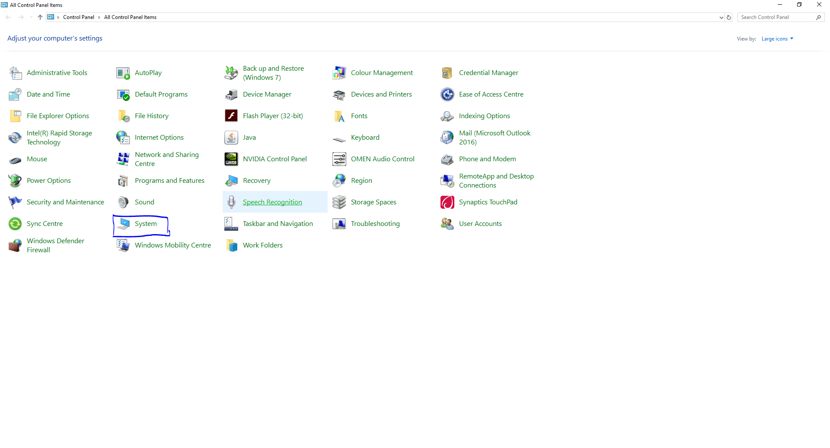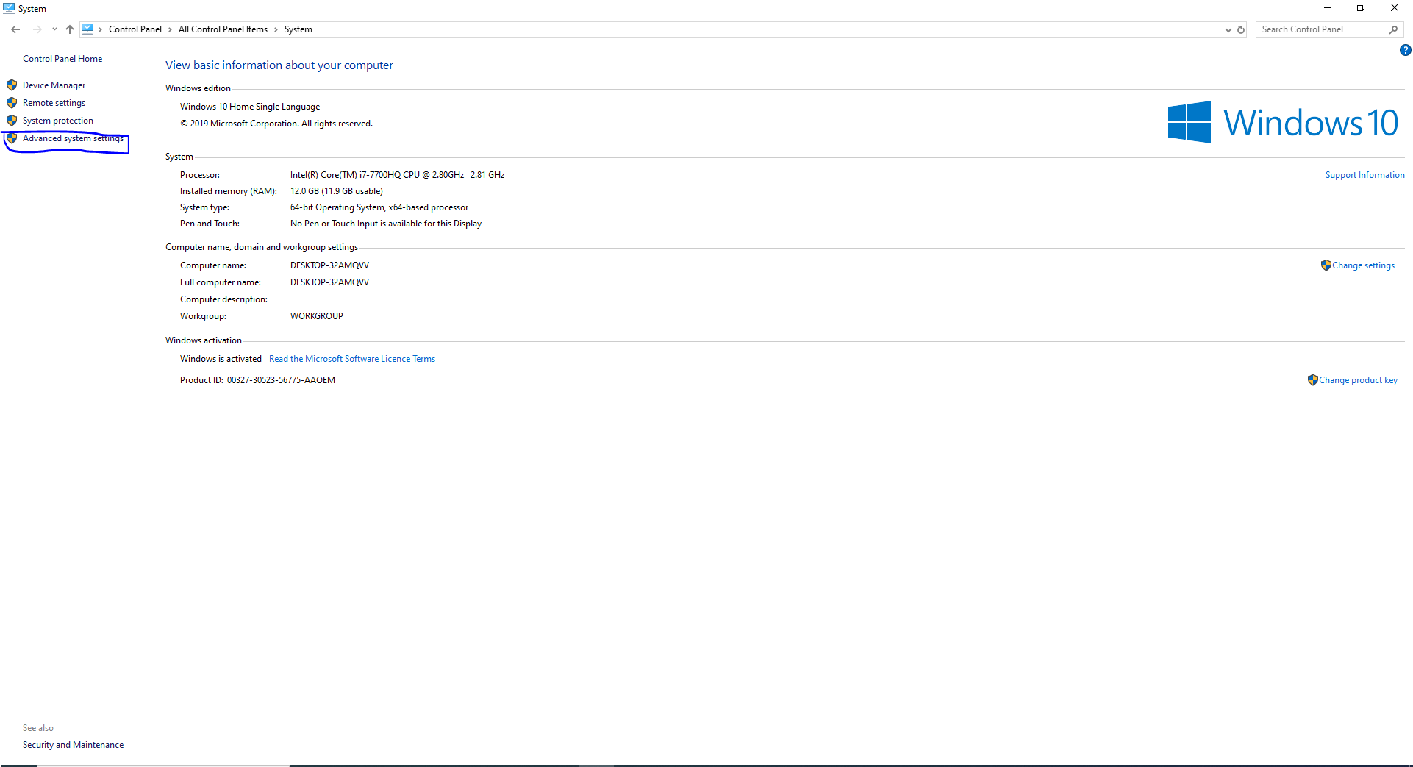
* Click on the Environment Variables button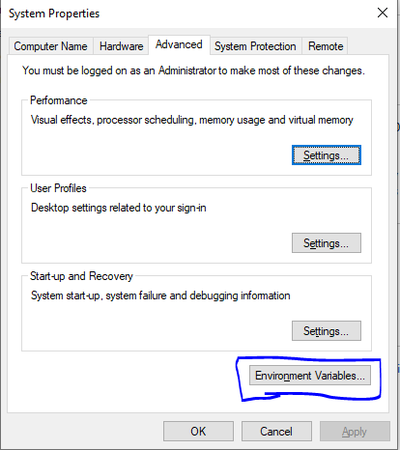
* Create a new Path to where xampp > php is. Here, xampp is install in D:/ and php is inside xampp folder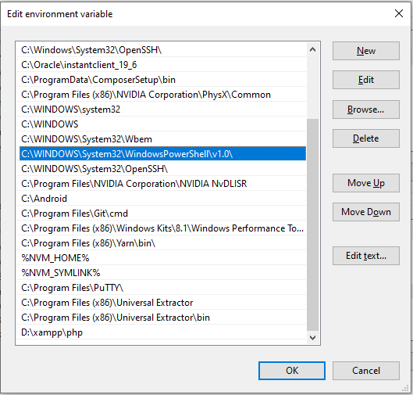

## Run PHP Application

* Navigate to the PHP application folder 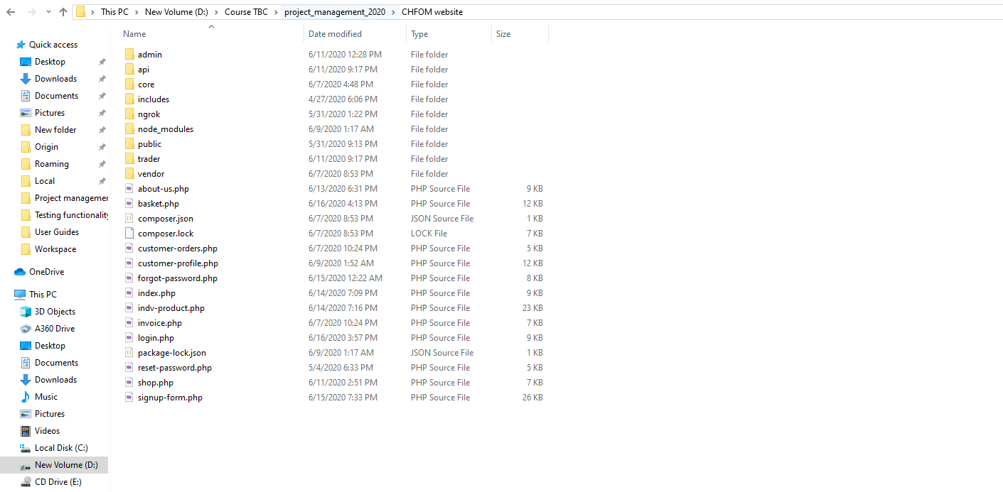
* press Alt + D. This will select the explorer input in the top.

Type cmd to open the command prompt.

Alternatively, you can open command prompt and change the directory to this location. 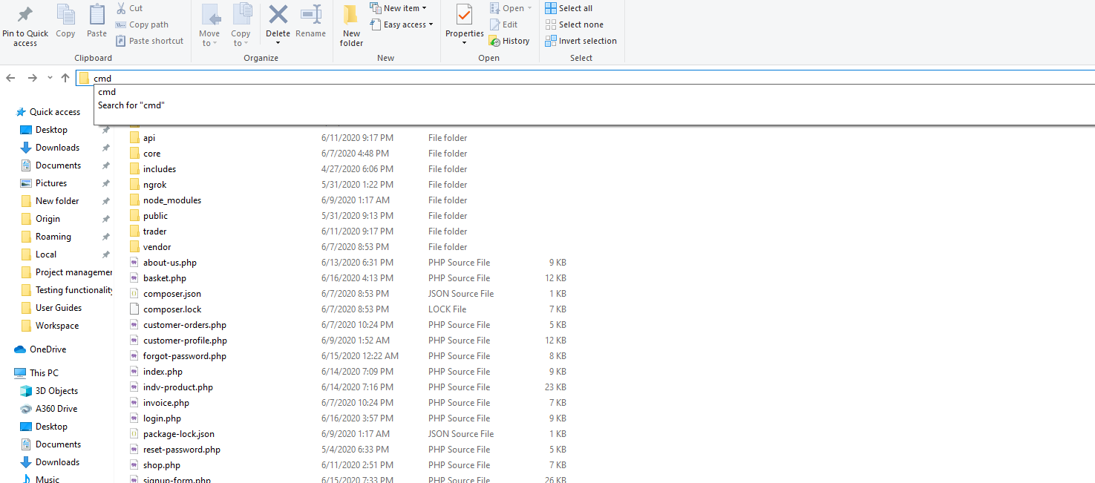

* Run command: php -S localhost:80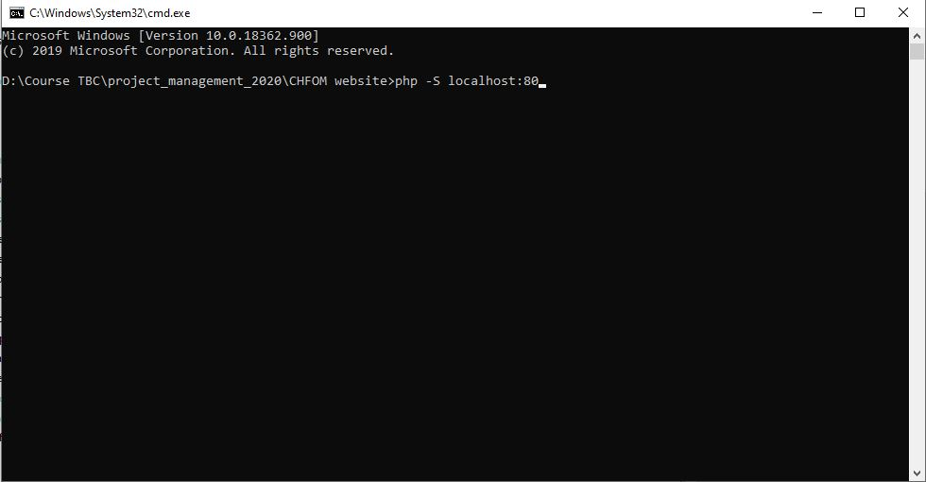
* After pressing Enter, you can see the following message 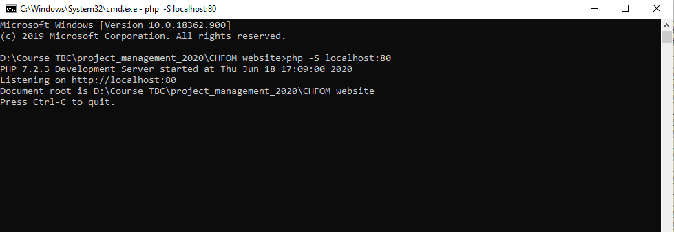
* Now, you can access the website through the link http://localhost.